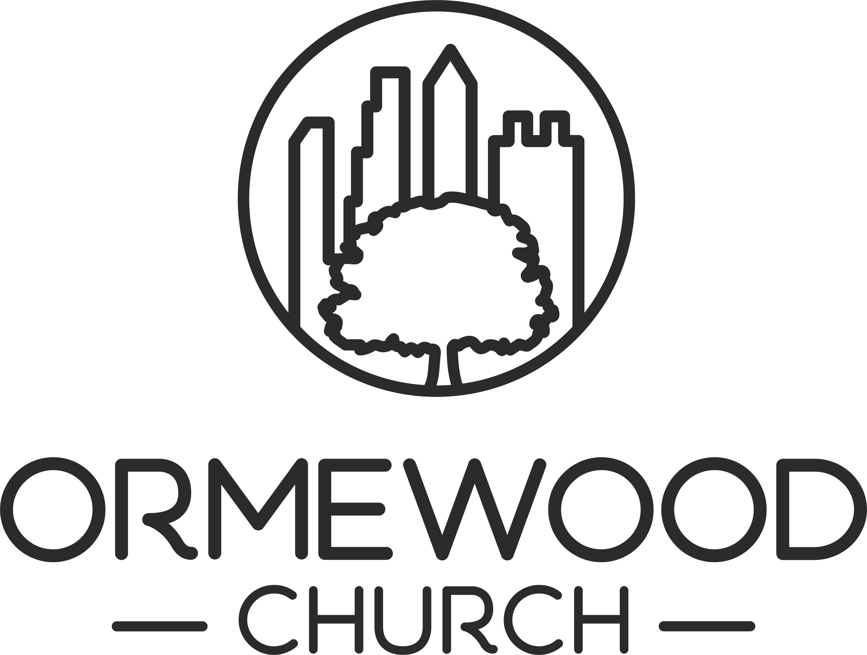
SHARED COMMUNITY FUND

Overview of Purpose

The purpose of this Fund is to steward the money entrusted to Ormewood Church back into the community with congregational participation. You can apply to spend this money on a project or non-profit that supports the mission of Ormewood Church. We hope these funds help start, support, or enable folks in our neighborhood and beyond to do good in the world. To this end, we welcome the opportunity to financially support mission-aligned groups and endeavors to the process outlined below.

Who Can Apply

This fund is set up to enable members and regular attenders of Ormewood Church to recommend where financial assistance or support is needed in our spheres of interaction. Members or regular attenders of Ormewood Church are able to apply for funds in groups of two or more.

Parameters of the Fund

These funds can be sent to individuals or to nonprofit organizations. If sent to a nonprofit organization, there are not strict rules as to its use. For example, the funds can be applied to events, programs, or general operating expenses.

Applicants are encouraged to list their full request with the understanding that the funds offered are contingent on our fiscal year’s projected budget and fiscal or missional priorities established by the Leadership Team.

Review of requests will occur at Leadership Team meetings. Estimated disbursement is quarterly. The Leadership Team reserves the right to review and disperse funds on an alternative schedule based on emergency situations, for example emergency funds sent to victims of Hurricane Helene.

All funds requests must align with our shared mission and values:

Cultivating a shared community of curiosity, spirituality, and belonging.

Welcome others. Open our minds. Be of service. Participate.
SHARED COMMUNITY FUND
Cultivating a shared community of curiosity, spirituality, and belonging.

Ormewood Church would like to partner with you in discerning areas where financial support would do good in our communities. Please fill out this application to request funds and send via email to office@ormewoodchurch.org.

Funding Requester Information

Names of two or more Ormewood Church members and/or a group name:

Preferred Contact Person and Email:

Funding Recipient Information

Organization or Individual’s Name:
Contact Name (if organization):
Email:
Amount of Funds Requested:
Date by Which Funds Are Needed:

Funding Overview
Please respond to the following questions in no more than 200 words each. You may submit the request via email to the Clerk of the Leadership Team. This information can be found on the homepage of our website.

Describe the specific work or purpose for which this funding is being requested.

What will be the impact of this work?

If an organization:
What is the mission statement?

Who at Ormewood Church is currently involved or affiliated with the good work of the nonprofit?

If an individual, how are they connected with Ormewood Church or its people?

